DATA ANALYTICS PROJECT REPORT
Women's Clothing: Trends and Analysis
in the Fashion Industry
Correlation Analysis Using Pearson, Spearman, Kendall
and Hierarchical Clustering
Analysis focus: Measure numerical relationships, filter statistically and practically significant associations, and identify related variable groups through hierarchical clustering.

Executive Summary
This report examines relationships among customer age, product rating, recommendation status, and positive-feedback count in a women's clothing review dataset. Three complementary metrics - Pearson, Spearman, and Kendall - were implemented to distinguish linear association from rank-based monotonic association. Statistical significance was evaluated at alpha = 0.05, while a minimum absolute correlation of 0.20 was used to retain only practically meaningful relationships.
The analysis identified one clear and stable relationship: Rating and Recommended IND were strongly and positively associated across all three methods (Pearson r = 0.7923, Spearman rho = 0.6935, Kendall tau = 0.6484). Hierarchical clustering placed these variables together, reinforcing the conclusion that recommendation behaviour is closely connected with the rating assigned by a customer.
Primary finding: Customers who assign higher ratings are substantially more likely to recommend the clothing item. Other observed associations are statistically detectable but practically very weak.

1. Project Background
Customer reviews provide direct evidence about satisfaction, recommendation behaviour, and engagement with fashion products. Correlation analysis helps determine whether numerical review features move together and whether apparent relationships remain consistent under different statistical assumptions.

1.1 Task Objective
- Compute Pearson, Spearman, and Kendall correlation coefficients for meaningful numerical variables.
- Calculate p-values and dynamically filter correlations using statistical and practical thresholds.
- Create standard and clustered heatmaps for visual comparison.
- Use hierarchical clustering to identify groups of related variables.
- Translate statistical results into fashion-industry and customer-behaviour insights.

2. Dataset Description
The dataset contains 23,486 customer-review records and 11 original columns. Four meaningful numerical variables were selected. The columns 'no' and 'Clothing ID' were excluded from the main analysis because they are identifiers rather than measured customer or review characteristics.
Variable | Type | Meaning | Unique values
Age | Integer | Customer age in years | 77
Rating | Integer/ordinal | Product rating from 1 to 5 | 5
Recommended IND | Binary | 1 = recommended; 0 = not recommended | 2
Positive Feedback Count | Integer/count | Number of positive votes on a review | 82

2.1 Data Quality Assessment
All four selected numerical columns contained zero missing values. Missing values in Title, Review Text, Division Name, Department Name, and Class Name did not affect this numerical-correlation task. Positive Feedback Count was strongly right-skewed and contained high observations, while Rating was concentrated toward higher values. These distributional characteristics justified the use of rank-based metrics in addition to Pearson correlation.

3. Methodology

3.1 Pearson Correlation
Pearson correlation measures the strength and direction of a linear relationship between two variables. It is sensitive to extreme values and is most informative when the relationship is approximately linear. For a binary variable such as Recommended IND, its correlation with a numerical variable is equivalent to a point-biserial interpretation.
r = cov(X,Y) / (sigma_X sigma_Y)

3.2 Spearman Rank Correlation
Spearman correlation applies Pearson correlation to ranked values. It measures monotonic association and is more robust to skewness and extreme observations. This is appropriate for ordinal ratings and the skewed positive-feedback variable.

3.3 Kendall Rank Correlation
Kendall's tau estimates rank agreement through concordant and discordant observation pairs. It is particularly useful when variables contain many tied values, as occurs for ratings and the binary recommendation indicator.

3.4 Dynamic Significance Filtering
A relationship was retained only when its p-value was below 0.05 and its absolute coefficient was at least 0.20. The strength threshold prevents a very large sample from making negligible effects appear important merely because they are statistically significant.
Condition | Threshold | Purpose
Statistical significance | p < 0.05 | Reject insufficient-evidence relationships
Practical strength | |correlation| >= 0.20 | Exclude negligible effects
Consistency | Same direction | Verify stability across metrics

3.5 Hierarchical Clustering
A correlation distance of 1 - |correlation| was calculated and average-linkage hierarchical clustering was applied. Strongly related variables therefore had smaller distances and joined earlier in the dendrogram. Absolute correlation was used for clustering so that both strong positive and strong negative relationships could be recognised as related patterns.

4. Results

4.1 Correlation Coefficients
Variable pair | Pearson | Spearman | Kendall | All p < .05
Age - Rating | 0.0268 | 0.0311 | 0.0241 | Yes
Age - Recommended IND | 0.0306 | 0.0310 | 0.0256 | Yes
Age - Positive Feedback Count | 0.0431 | 0.0756 | 0.0561 | Yes
Rating - Recommended IND | 0.7923 | 0.6935 | 0.6484 | Yes
Rating - Positive Feedback Count | -0.0650 | -0.0683 | -0.0575 | Yes
Recommended IND - Positive Feedback Count | -0.0690 | -0.0809 | -0.0729 | Yes
Note: Statistical significance alone does not imply a meaningful effect. Coefficients below |0.20| were excluded from the final practical interpretation.

4.2 Correlation Heatmaps
The heatmaps below compare the direction and magnitude of all three correlation metrics. The Rating-Recommendation cell is consistently the darkest positive cell, whereas other off-diagonal cells remain close to zero.
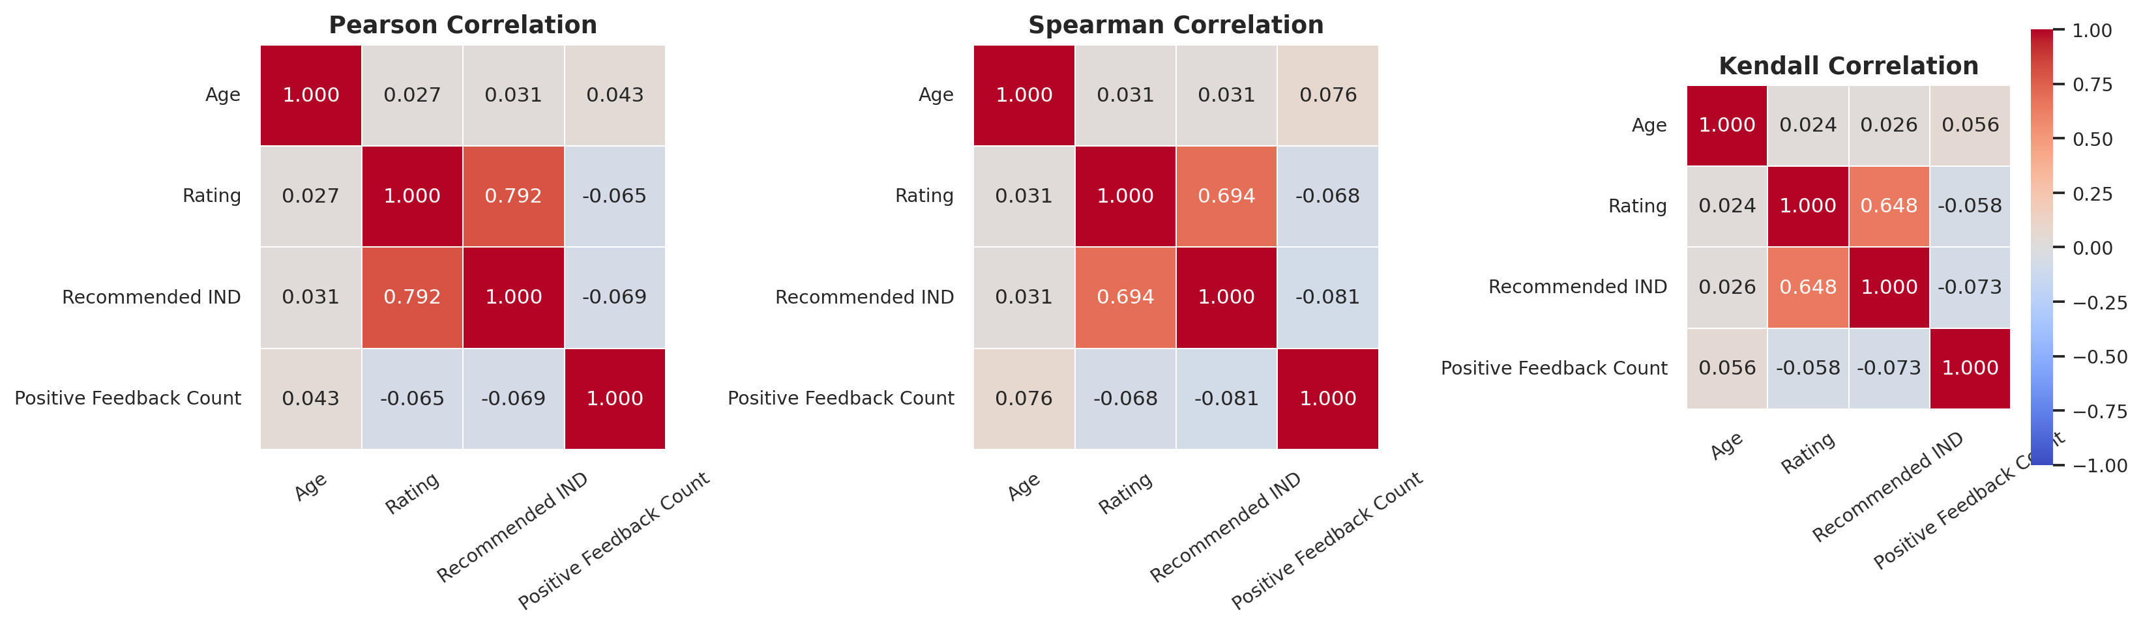
Figure 1. Pearson, Spearman, and Kendall correlation heatmaps.

4.3 Main Relationship
Rating and Recommended IND produced coefficients of 0.7923, 0.6935, and 0.6484 under Pearson, Spearman, and Kendall analysis respectively. All p-values were below 0.05. The shared positive direction and high magnitude show that the result is not dependent on a single metric or distributional assumption.
Interpretation: Recommendation status functions as a strong behavioural confirmation of the rating. Higher customer satisfaction, expressed through rating, aligns closely with willingness to recommend the item.

4.4 Other Relationships
- Age-Rating correlations ranged from 0.0241 to 0.0311, indicating virtually no meaningful association.
- Age-Recommendation correlations ranged from 0.0256 to 0.0310, so recommendation behaviour was not materially explained by age alone.
- Age-Positive Feedback was positive but very weak (Pearson 0.0431; Spearman 0.0756; Kendall 0.0561).
- Rating-Positive Feedback and Recommendation-Positive Feedback were slightly negative, but all coefficients remained below |0.10| and were practically negligible.

5. Hierarchical Clustering Results
The clustered Pearson heatmap reordered variables according to similarity in their absolute-correlation patterns. Rating and Recommended IND joined as the closest substantive cluster. Age and Positive Feedback Count remained separate because their associations with the main satisfaction variables were weak.
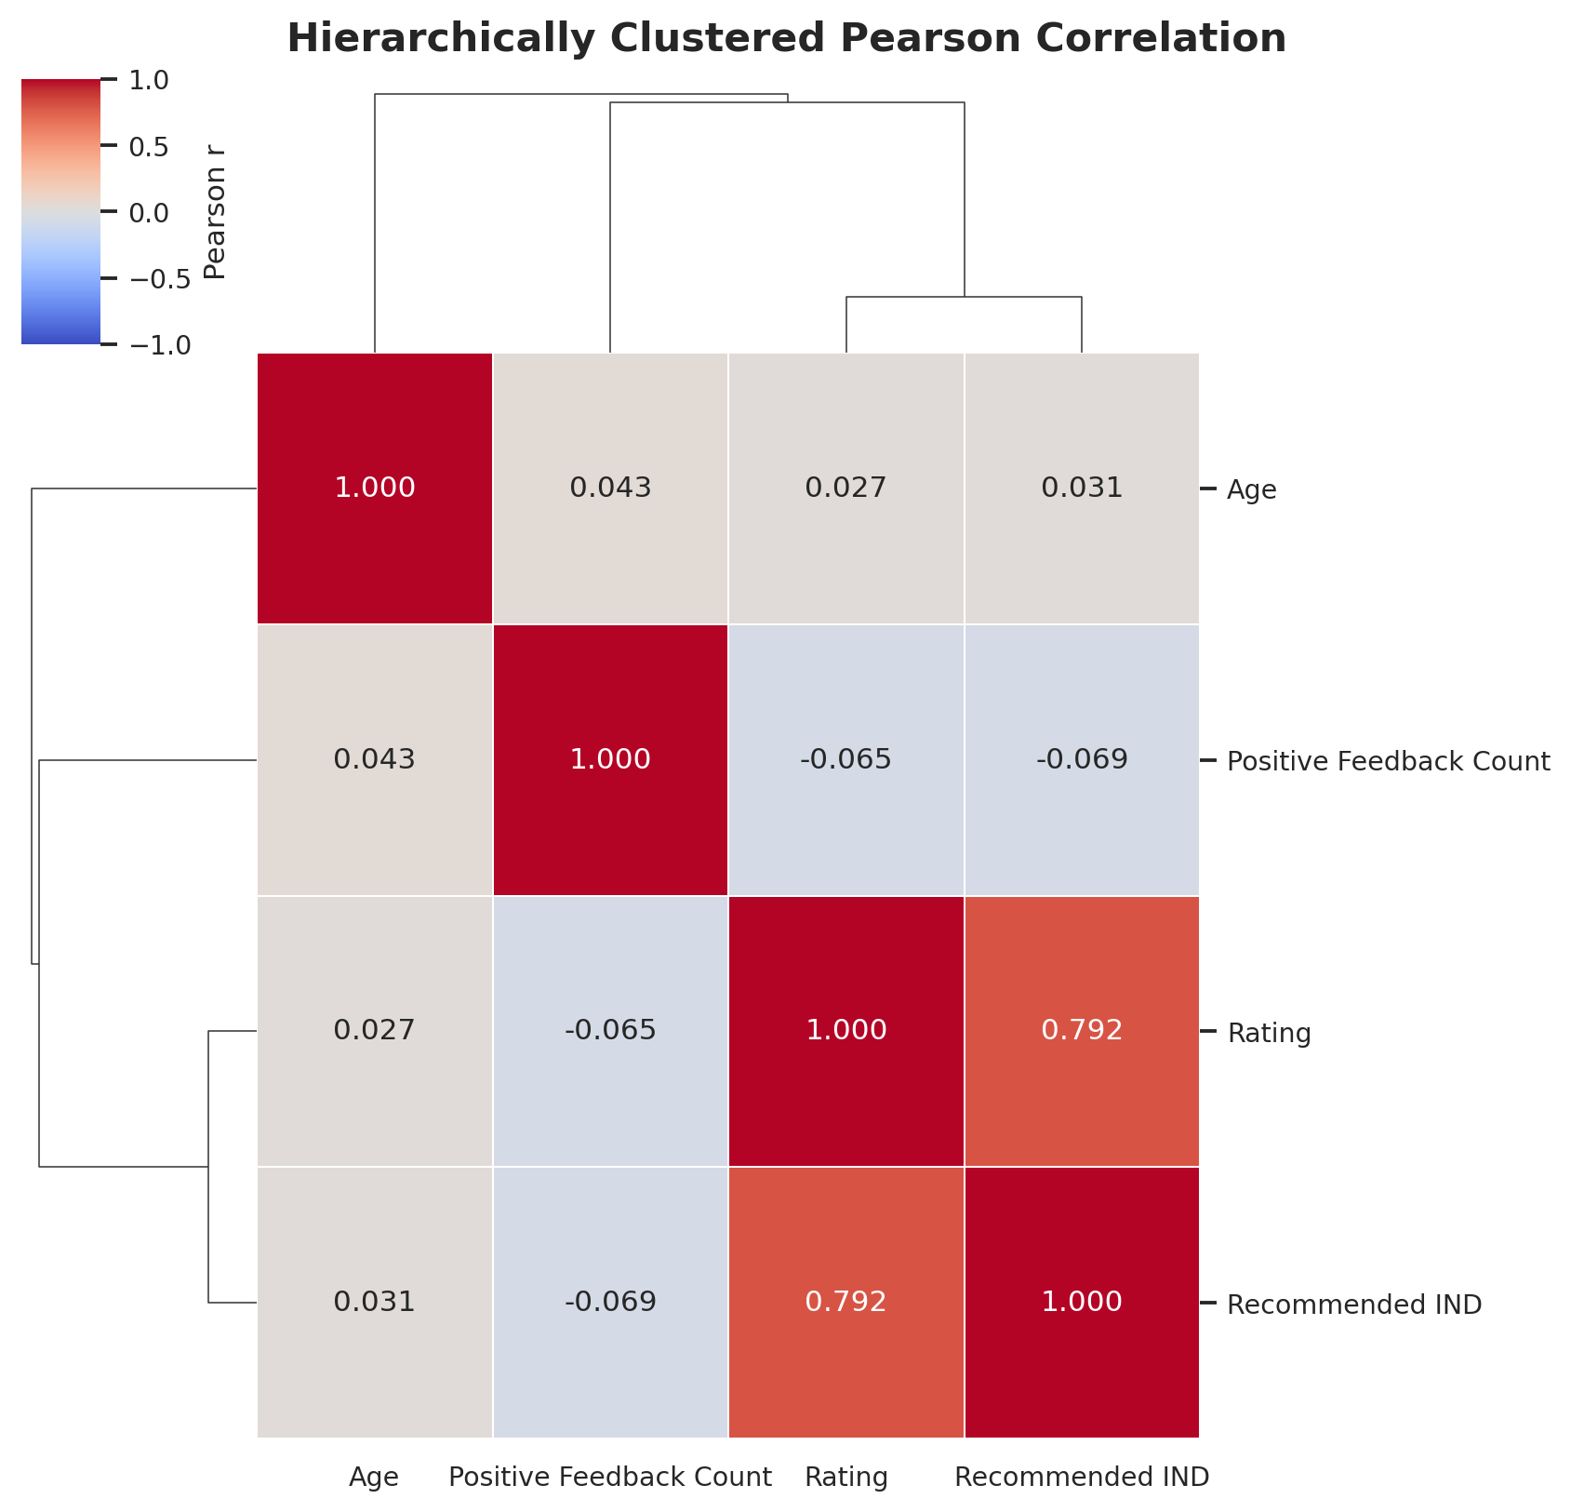
Figure 2. Pearson correlation heatmap with average-linkage hierarchical clustering.

6. Business and Fashion-Industry Insights
- Recommendation intent can be treated as a strong companion indicator to customer rating when monitoring product satisfaction.
- Low-rated products should be investigated alongside non-recommendation reviews to identify recurring issues involving fit, fabric, sizing, comfort, or design.
- Age alone should not be used to infer satisfaction or recommendation behaviour; richer segmentation variables such as clothing class, department, and review text are needed.
- Positive-feedback count measures review engagement or helpfulness rather than satisfaction. It should not be interpreted as a direct product-quality score.
- The Rating-Recommendation cluster may support dashboard design, customer-satisfaction monitoring, and later predictive modelling, while avoiding redundant interpretation of identifier columns.

7. Limitations
- Correlation measures association, not causation.
- Rating and recommendation are both customer-reported outcomes and may reflect common response behaviour.
- The analysis covers four numerical variables and does not directly incorporate review text or product categories.
- Very large sample size makes small coefficients statistically significant; practical thresholds remain essential.
- A binary recommendation variable has limited variation, so rank metrics contain many tied observations.

8. Conclusion
The project successfully implemented Pearson, Spearman, and Kendall correlations, p-value testing, dynamic significance filtering, heatmap visualisation, and hierarchical clustering. Across all analytical approaches, Rating and Recommended IND formed the only relationship that was both statistically significant and practically strong. The result demonstrates a stable positive association between product rating and recommendation behaviour in the women's clothing review dataset.
Age and Positive Feedback Count did not exhibit practically meaningful relationships with customer satisfaction or recommendation. Therefore, the most defensible analytical conclusion is that rating and recommendation represent a coherent satisfaction cluster, while the remaining numerical variables capture different dimensions of customer or review behaviour.

References
Kendall, M. G. (1938). A new measure of rank correlation. Biometrika, 30(1/2), 81-93.
Pearson, K. (1895). Notes on regression and inheritance in the case of two parents. Proceedings of the Royal Society of London, 58, 240-242.
Spearman, C. (1904). The proof and measurement of association between two things. The American Journal of Psychology, 15(1), 72-101.
Software: Python, pandas, NumPy, SciPy, Matplotlib, and Seaborn.

